CS Bridge Module 23 Processes and Threads

1. Processes and Threads

1.1 CS Bridge: Processes & Threads

Notes:

1.2 Introduction
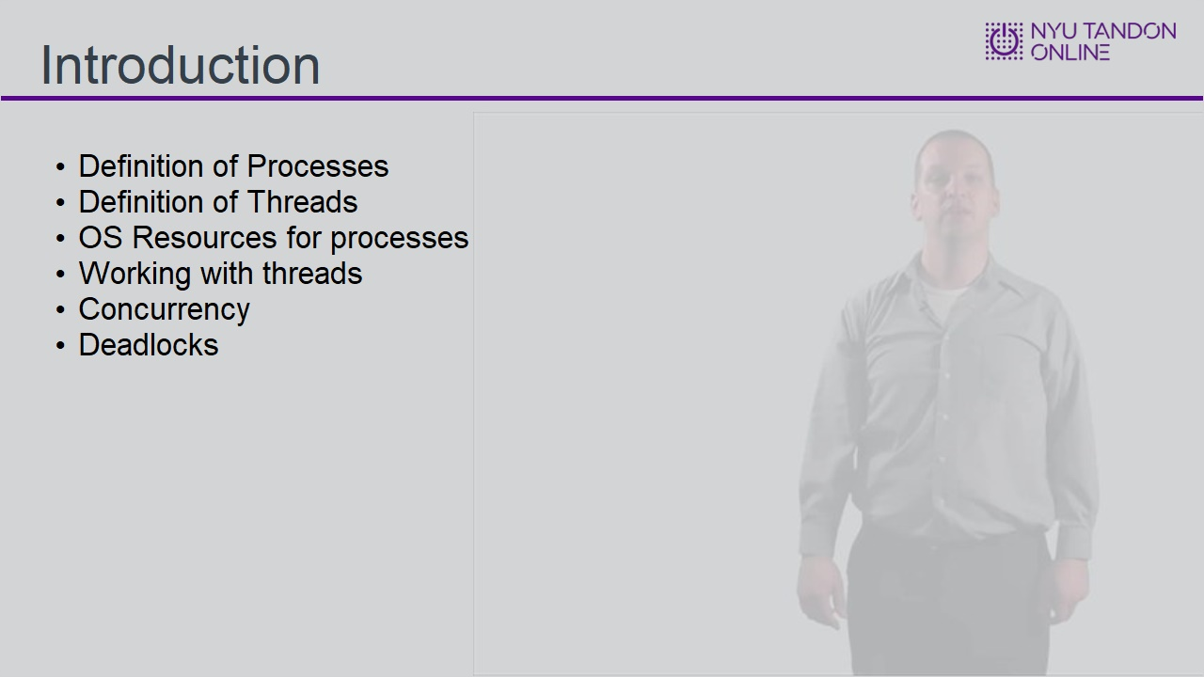
Notes:

1.3 What is a Process?
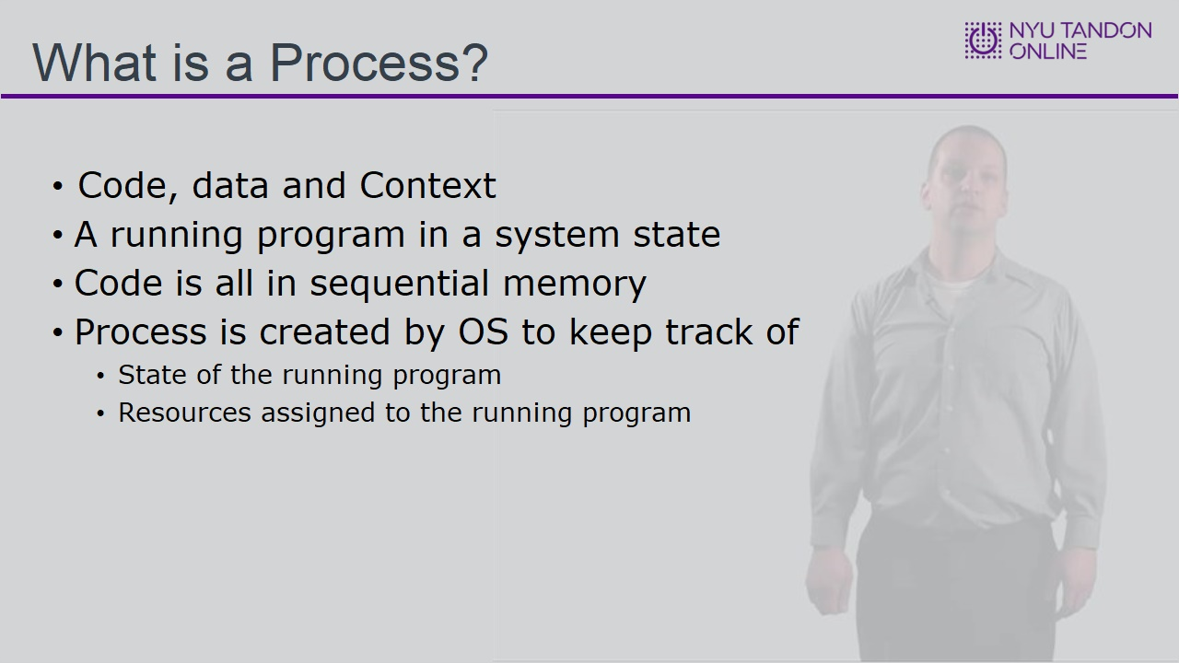

1.4 5 state process model
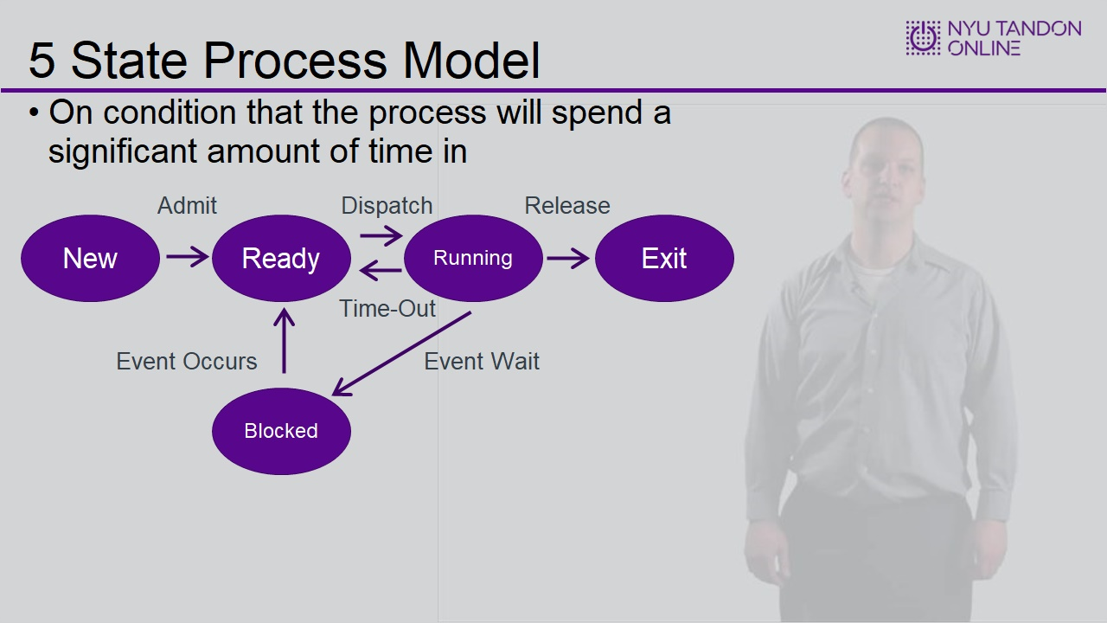

1.5 Suspension
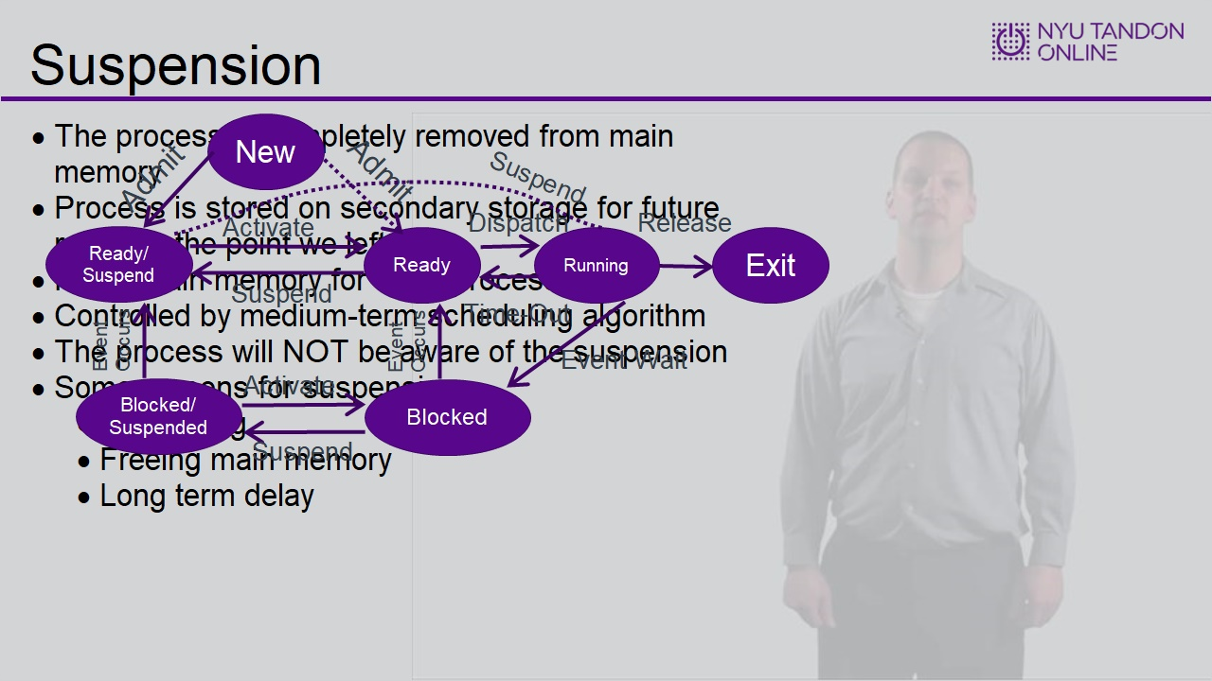

1.6 Process Image – The PCB
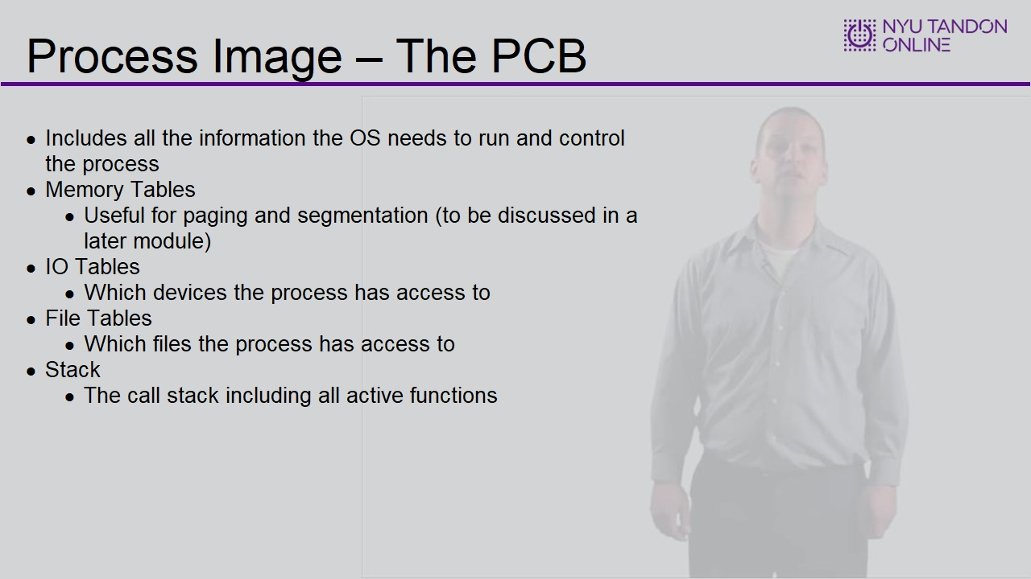

1.7 Contents of a PCB
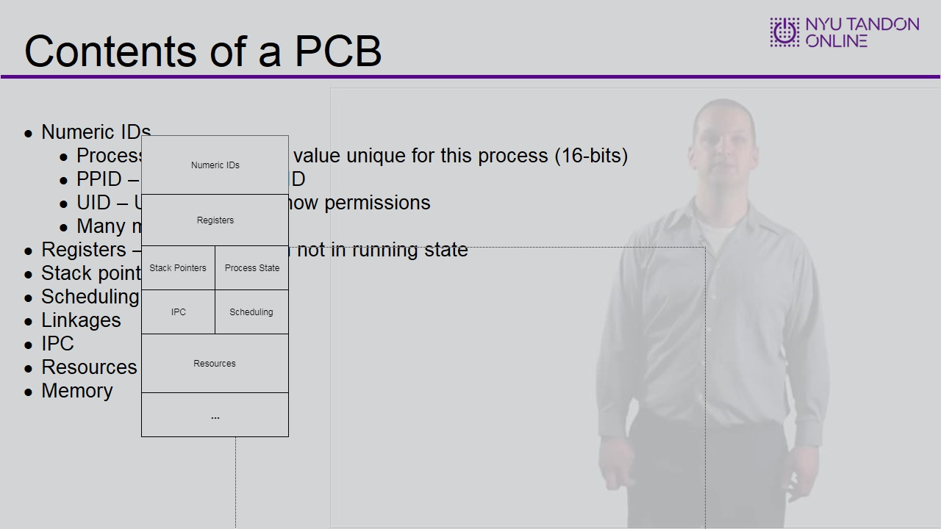

1.8 Modes
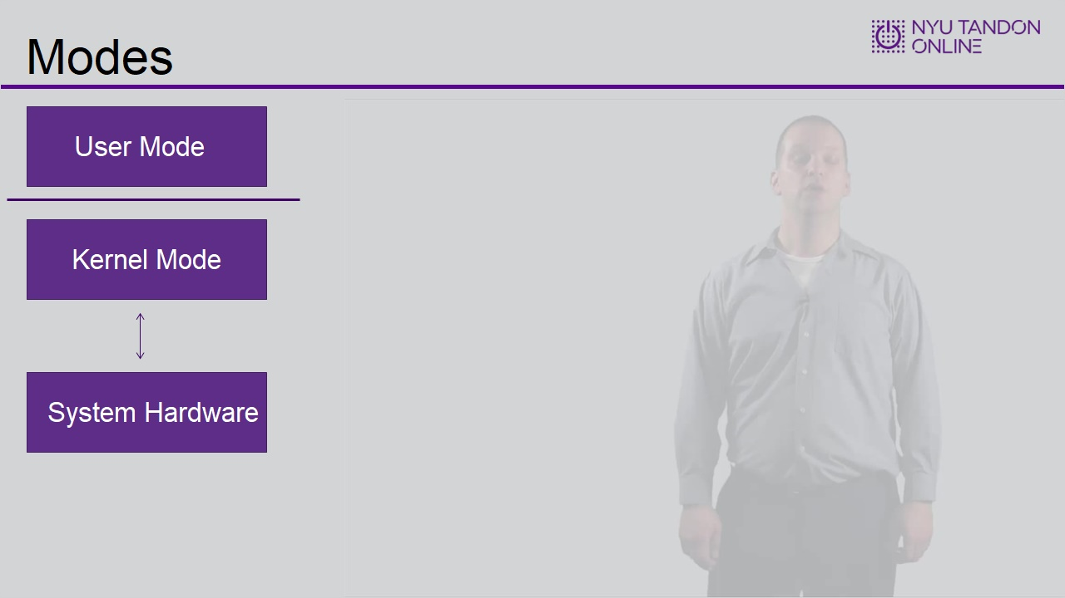

User Mode (Slide Layer)
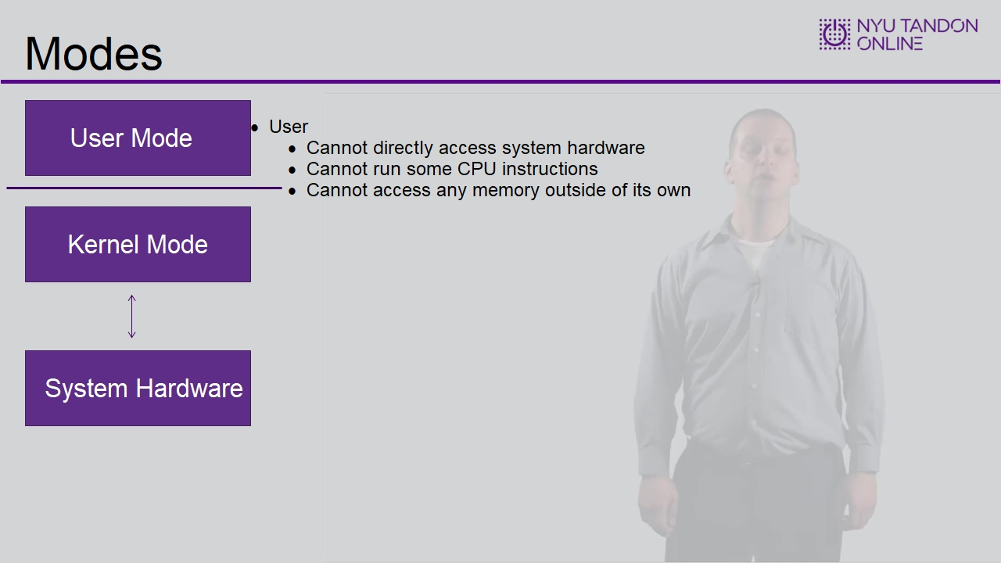

Kernel Mode (Slide Layer)
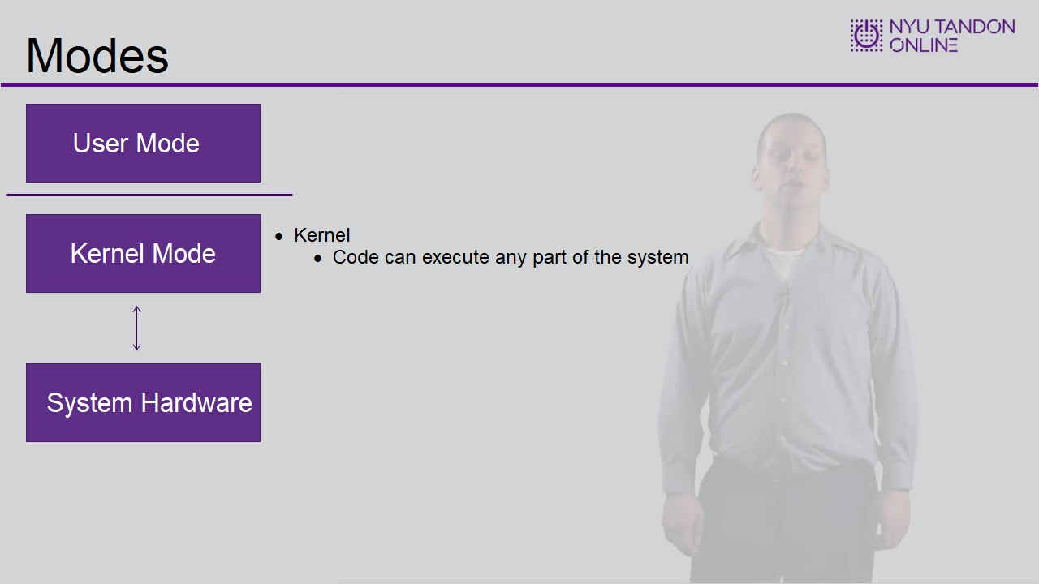

System Hardware (Slide Layer)
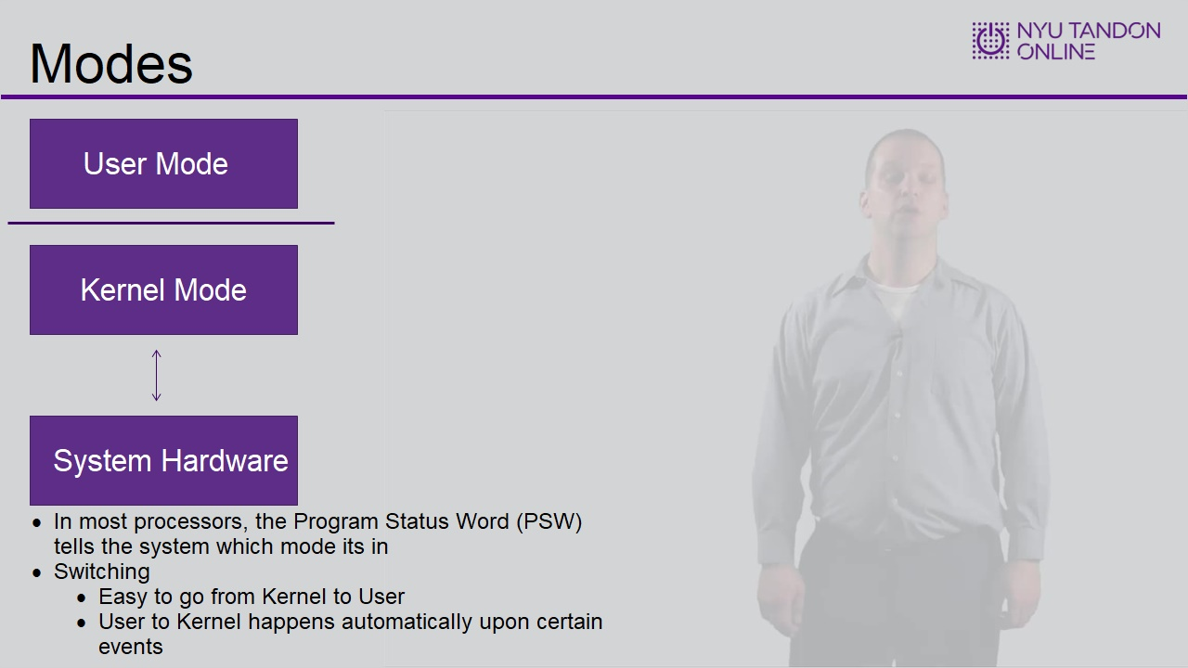

1.9 Process Switching
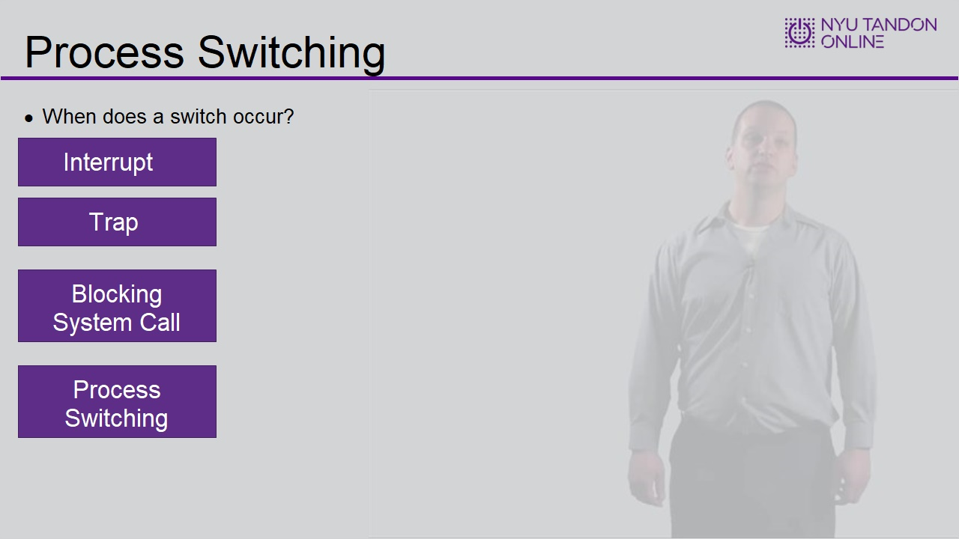

Interrupt (Slide Layer)
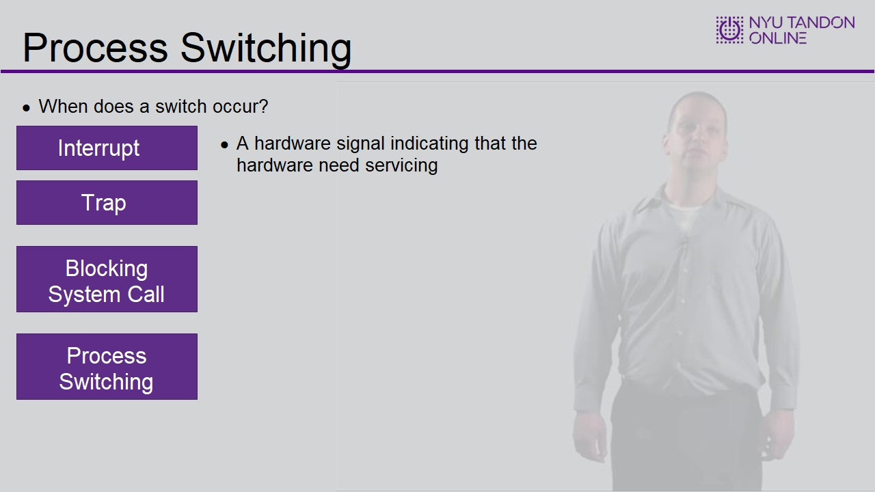

Process (Slide Layer)
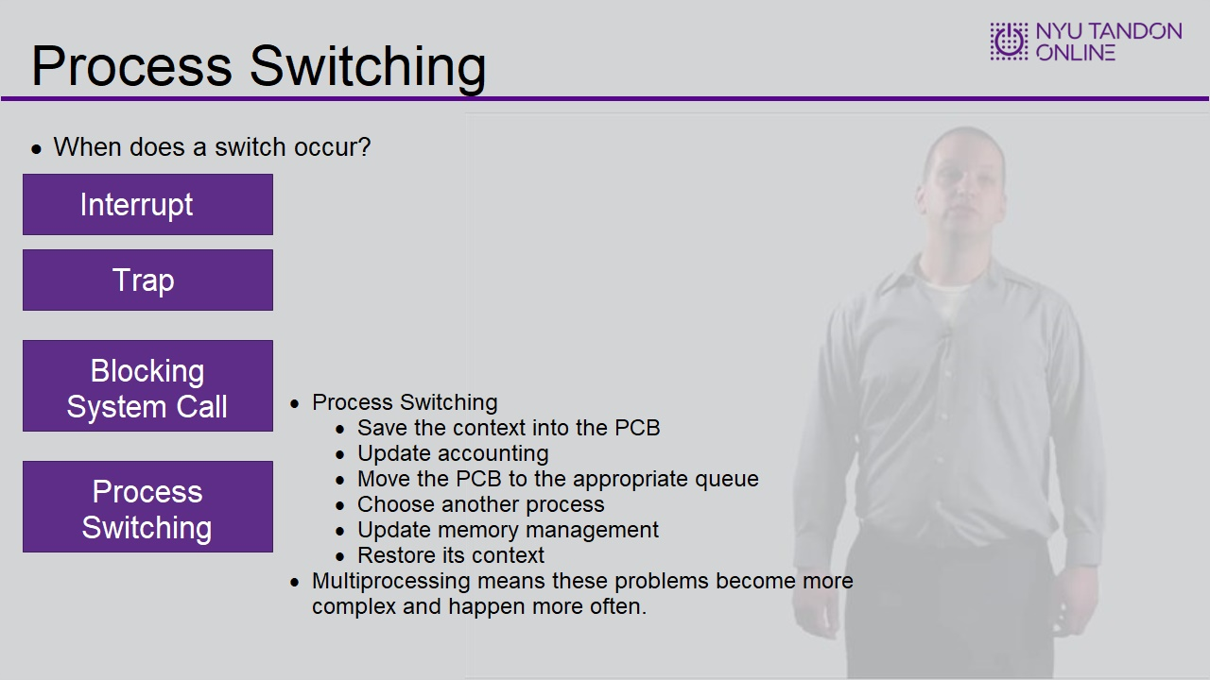

Trap (Slide Layer)
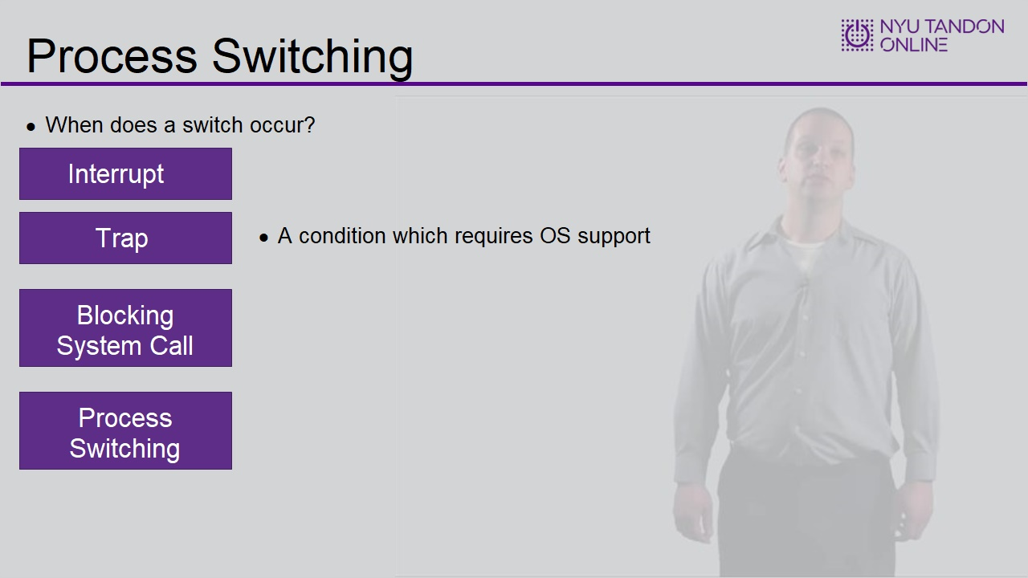

Blocking System Call (Slide Layer)
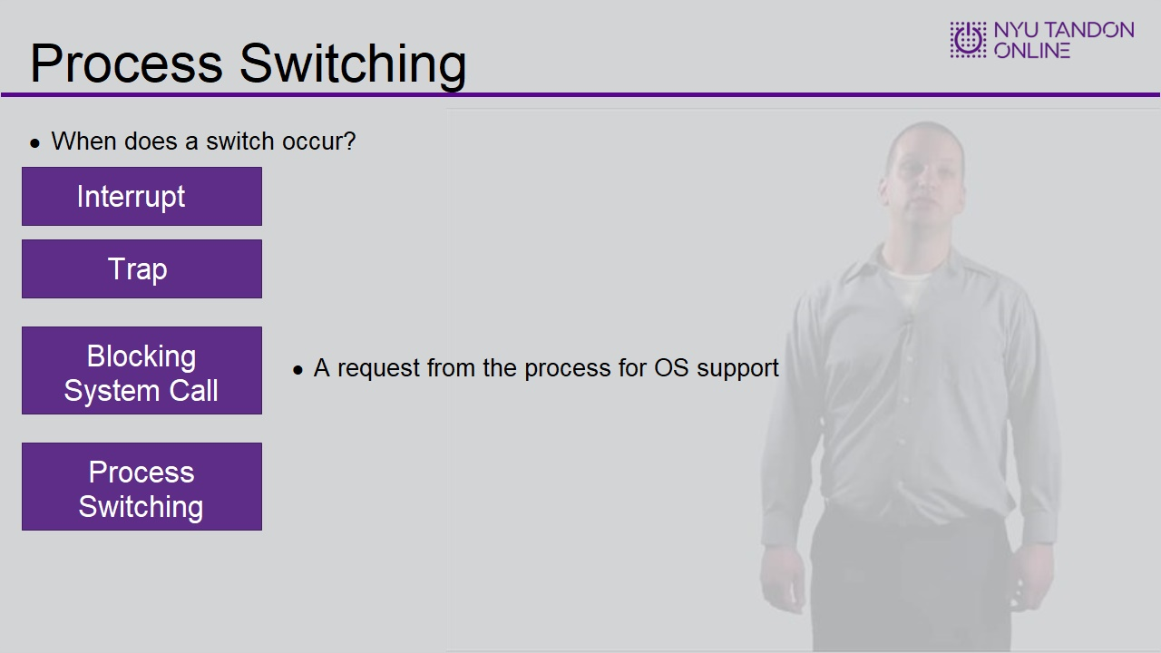

1.10 Threads
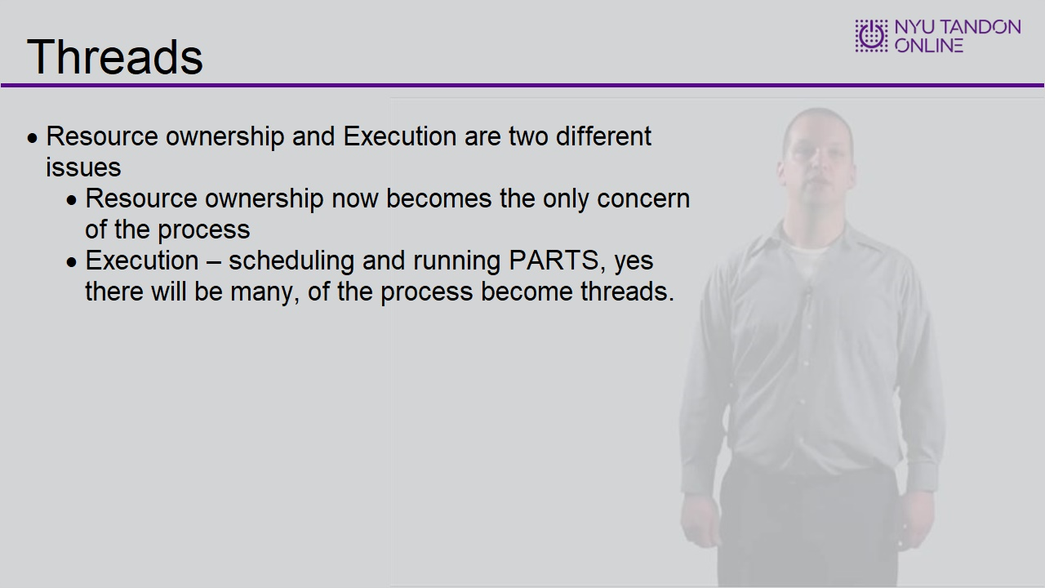

1.11 What Is Where In The Multithreaded Environment
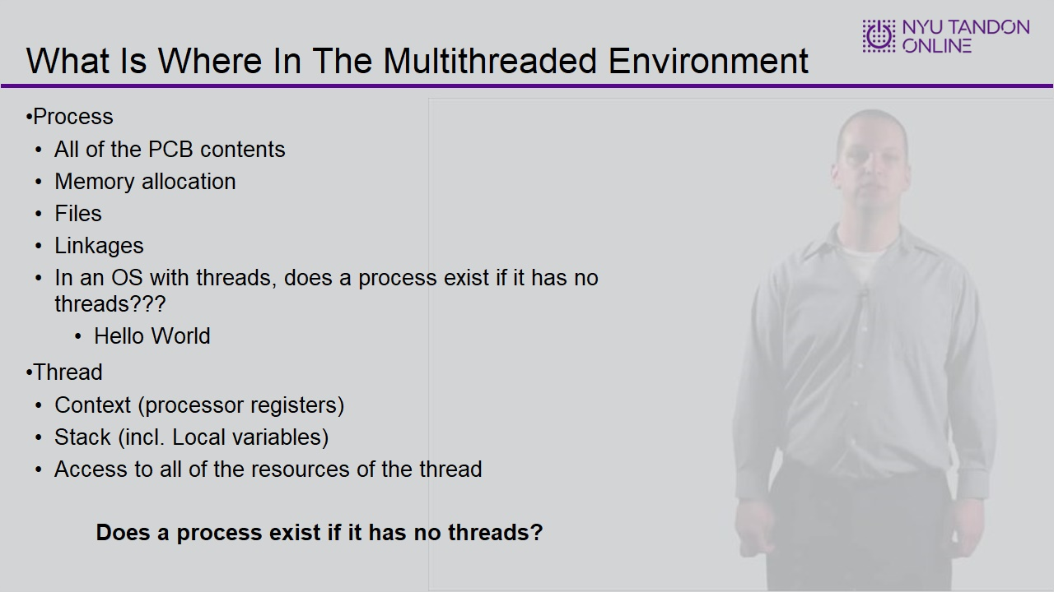

1.12 Reasons for multithreading
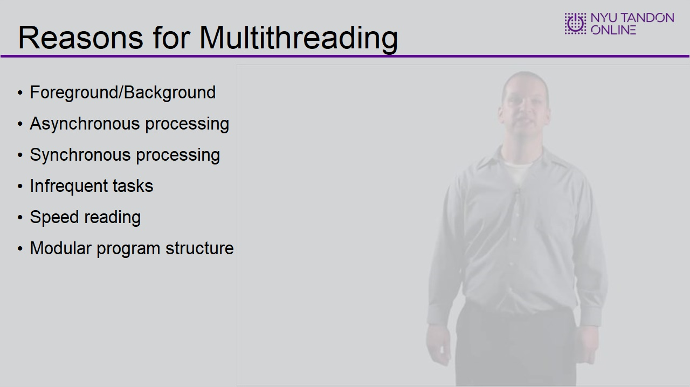

1.13 Performance example
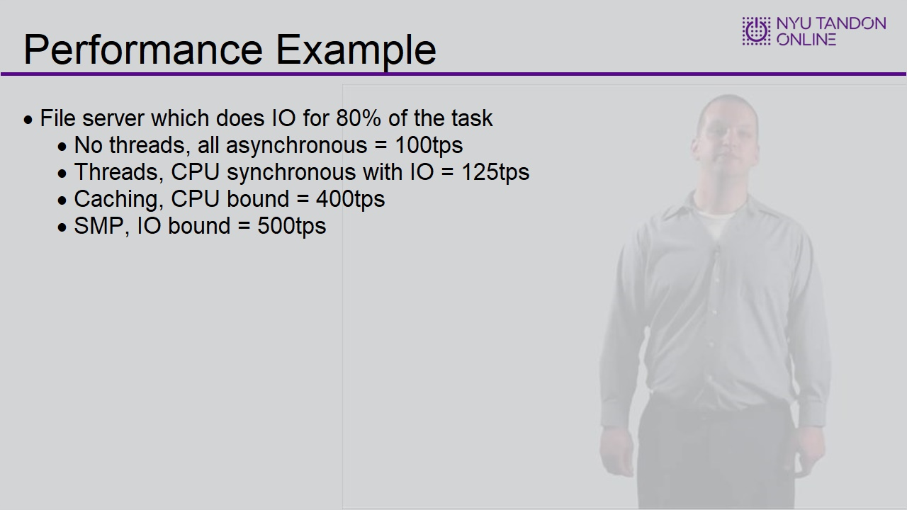

1.14 Thread states/Operation
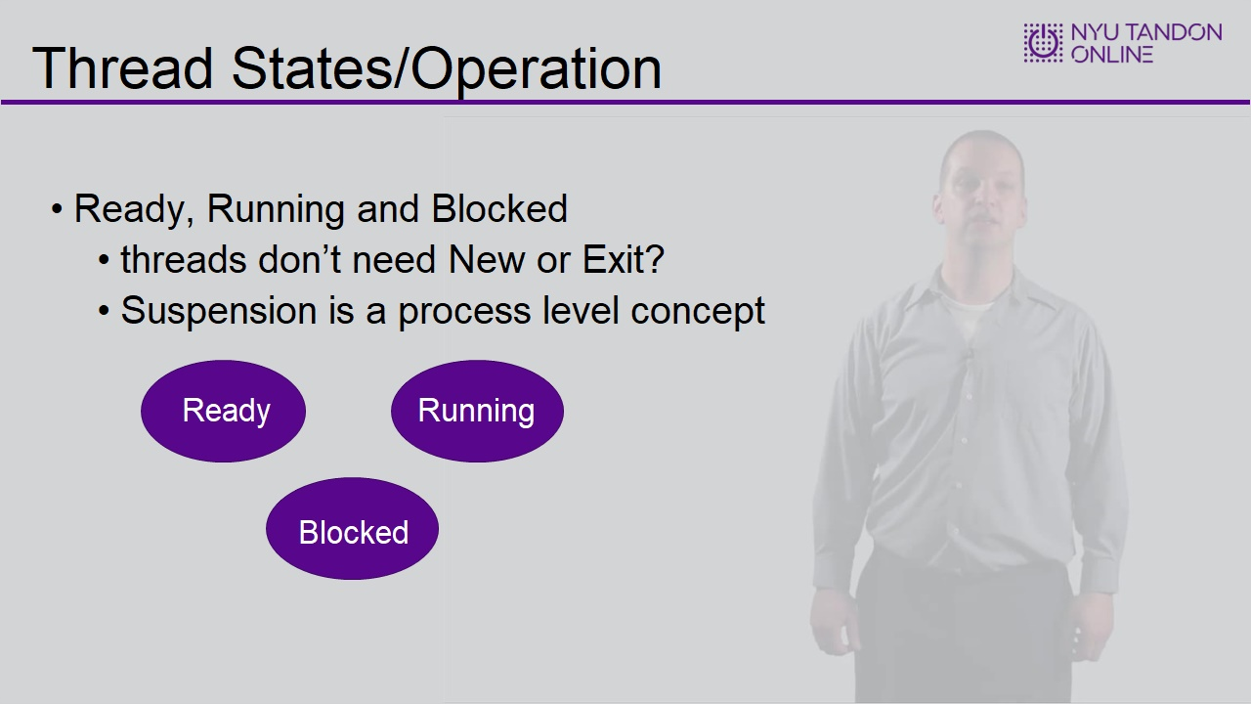

Untitled Layer 1 (Slide Layer)
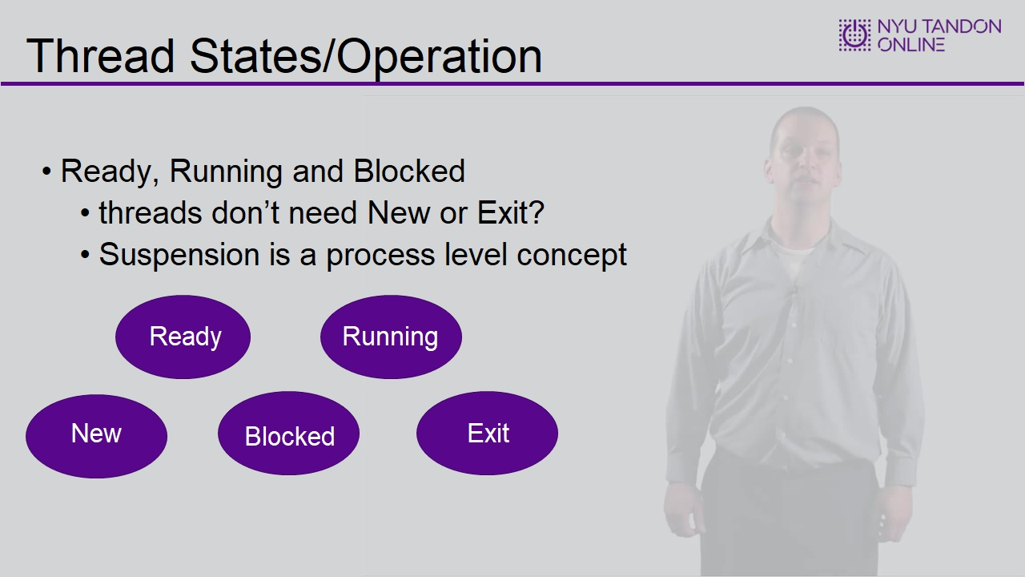

1.15 What are the downsides
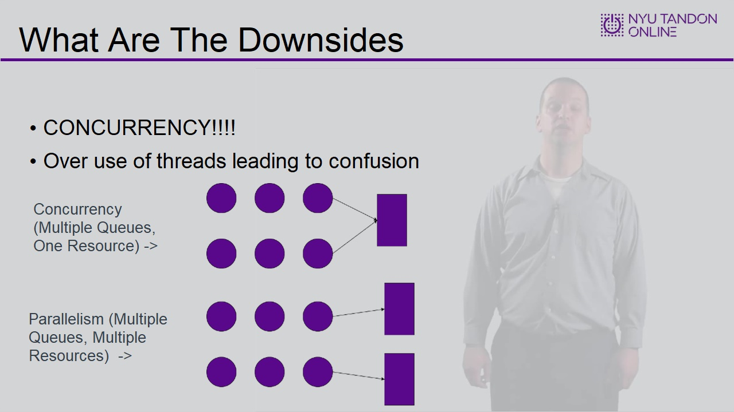
Notes:

1.16 Implementation of Threads
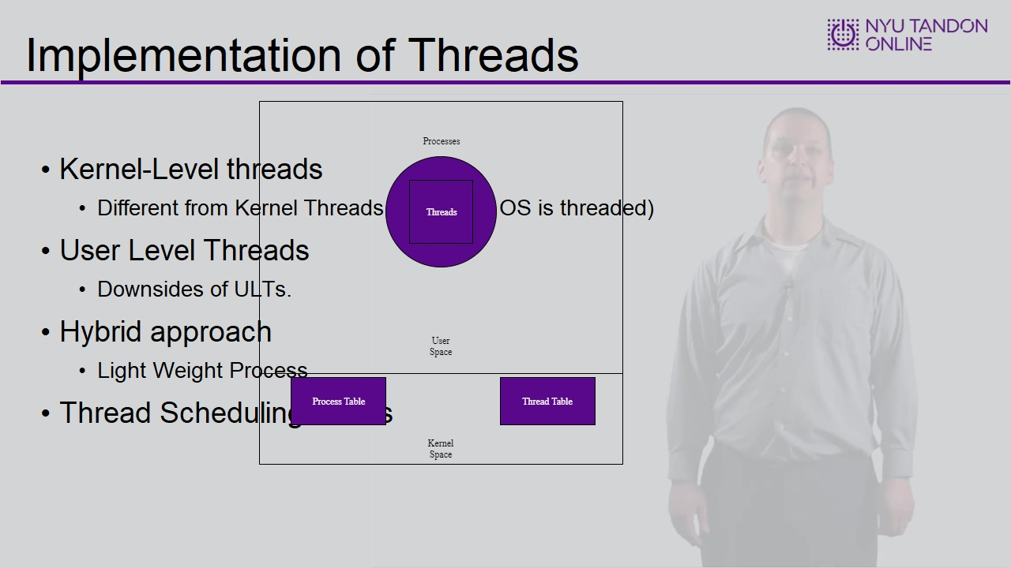

Untitled Layer 1 (Slide Layer)

1.17 End of Module


